Assessment, Marking and Feedback policy.

Purpose
• Supports pupil progress in every lesson
• Provides clear, actionable next steps
• Engages pupils in reflecting on their learning
• Enables staff to identify gaps and adapt teaching effectively

Core Principles
Feedback is timely, specific, and focused on improvement, ensuring that pupils clearly understand their next steps in learning. Pupils are given regular opportunities to respond to feedback, embedding a cycle of reflection and continuous improvement. Assessment—including approaches linked to Embedding Formative Assessment (EFA)—is used effectively to inform teaching, identify gaps, and adapt instruction to meet pupil needs. EFA strategies, such as effective questioning, live marking, peer and self-assessment, and responsive teaching, enable teachers to gather real-time information about pupil understanding and adjust lessons accordingly. This approach supports deeper learning, increases pupil engagement, and ensures misconceptions are addressed promptly. Marking practices remain efficient and sustainable, prioritising methods that have the greatest impact on pupil outcomes while also supporting staff workload and wellbeing.

Live Marking Expectations
Live marking is expected in all lessons and is the primary method of feedback. Teachers and support staff provide immediate, in-the-moment feedback as pupils are working, addressing misconceptions and extending learning in real time. This may include verbal feedback, short written prompts, or annotations such as highlighting and ‘VF’ to indicate verbal feedback. Pupils are expected to act on this feedback within the lesson, ensuring that improvements are made immediately and learning is continuously developed.

Pupil Feedback and Reflection
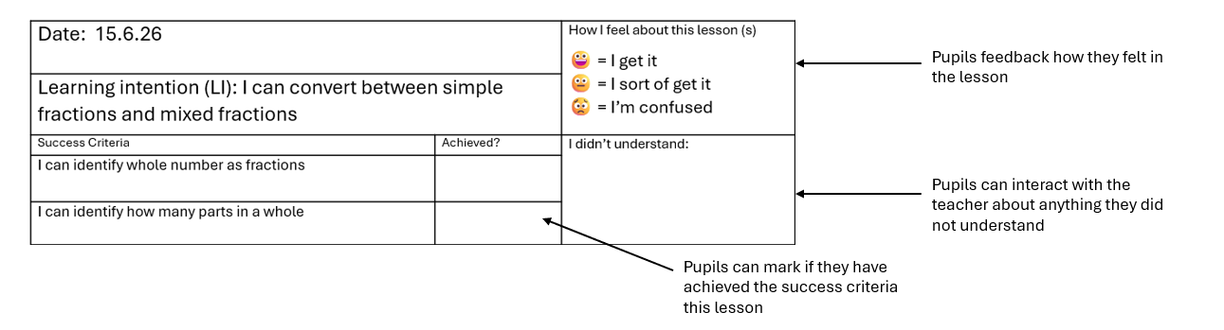
At the end of each lesson, pupils reflect on their learning using the Success Criteria Sheet. They assess their progress against the lesson Intention, identify what they have achieved, and highlight areas where they need further support. This structured reflection encourages ownership of learning, reinforces understanding, and provides valuable feedback for teachers to inform future planning and address emerging gaps.

Written Feedback
Written feedback is used selectively and strategically where it will have the greatest impact on pupil progress. It focuses on identifying strengths and providing clear, concise next steps rather than excessive commentary. Opportunities are built into lessons for pupils to read, understand, and respond to this feedback, ensuring it leads to meaningful improvement.
Formal Assessment
Formal assessments are conducted periodically to evaluate pupil progress and provide a clear picture of attainment over time. These assessments are aligned to the Learning Intentions over a period of learning, marked accurately and consistently, with outcomes recorded in the school’s tracking systems. The resulting data is used to identify individual and group gaps, inform teaching adjustments, and plan targeted interventions, ensuring that assessment directly contributes to raising standards.
Consistency and Monitoring
Leaders monitor the implementation and impact of this policy through a range of strategies, including book looks, lesson visits, pupil voice, and data analysis. This ensures consistency in practice across the school, supports staff development, and guarantees that feedback is having a positive impact on pupil outcomes.
Workload Considerations
This policy is designed to ensure that marking is both effective and manageable. Live marking is prioritised to reduce the need for extensive written feedback outside of lessons, while written marking is purposeful and focused. Whole-class feedback strategies may be used where appropriate to maximise impact while maintaining a sustainable workload for staff.
Impact
Effective implementation of this policy ensures that pupils understand how to improve, misconceptions are addressed promptly, and teaching is responsive to pupil needs. Assessment information is used meaningfully to drive progress, resulting in improved outcomes for pupils alongside a manageable and purposeful approach to staff workload.

