

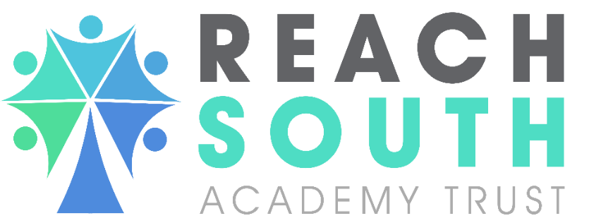

ANTI BULLYING POLICY

Approval Date | April 2026
Policy Owner
 | Dave Readman
Adopted by Trust Board
Review Date | April 2027

CONTENTS

Section | Description | Page No.
1. | Objectives
2. | Introduction
3. | Definition
4. | Roles and Responsibilities
5. | Reporting and Recording Incidents
6. | Prevention of Bullying
7. | Responding to Incidents of Bullying

- Objectives
1.1 At Peak Academy, we aim to provide a safe, happy and inspiring environment in which our students:
- feel valued and appreciate the beliefs, uniqueness and talents of others
- are happy, self-confident and resilient individuals
- love learning and have high expectations to achieve their potential
- are responsible, caring and active members of the community and wider society
- acquire the life skills needed to be safe and succeed in an evolving world

- Introduction

  - At Peak Academy, we want an environment for all students where they can experience a sense of belonging and safety regardless of their background or cultural identity. This Anti-Bullying policy links with a number of other Peak Academy policies. These include:

- Safeguarding
- Equal Opportunities Statement
- Behaviour/Relational Policy.
2.2 At Peak Academy, we recognise that bullying will not stop unless all members of the school community take collective responsibility to eliminate it.
- Definition

3.1 The Anti-Bully Alliance (www.anti-bullyingalliance.org.uk) define bullying as: ‘the repetitive, intentional hurting of one person or group by another person or group, where the relationship involves an imbalance of power. It can happen face to face or online’ Bullying is a subjective experience and can take many forms, making it extremely difficult to define. Children, young people and adults can instigate bullying. The nature of bullying is changing and evolving as technology develops. Bullying is harmful to all involved, not just the bullied, and can lead to self-doubt, lack of confidence, low self-esteem, depression, anxiety, self-harm and sometimes even suicide. Definitions are different and individuals have different experiences; however, from the accounts we have heard from children and young people we consider bullying to be:

- Repetitive, wilful or persistent
- Intentionally harmful, carried out by an individual or a group
- An imbalance of power leaving the victim feeling defenceless.
3.2 Bullying behaviour can be:
- Physical – pushing, poking, kicking, hitting, biting, pinching etc.
- Verbal - name calling, sarcasm, spreading rumours, threats, teasing, belittling.
- Emotional – isolating others, tormenting, hiding books, threatening gestures, ridicule, humiliation, intimidating, excluding, manipulation and coercion.
- Sexual – unwanted physical contact, inappropriate touching, abusive comments, homophobic abuse, exposure to inappropriate films etc.
- Online /cyber – posting on social media, sharing photos, sending nasty text messages, social exclusion
- Indirect - Can include the exploitation of individuals.
- Prejudice driven bullying: When bullying is driven by negative attitudes towards another group of people, or because the selected victim is seen as 'different' in some way, the prejudice itself needs to be tackled. Prejudice-driven bullying can become more entrenched or severe over time and it can eventually lead to hate crime. It can be related to negative views on – Race, religion or culture Special educational needs or disabilities Appearance or health conditions Sexuality and gender Perceived sexual orientation Any so called perceived ‘differences’

- Roles and Responsibilities

  - Governors will monitor and hold to account all of the Senior Leadership Team (SLT) to ensure the policy is appropriately implemented and accurate records kept.

  - The Head teacher will support, enable and monitor key staff to ensure the policy is implemented and reviewed regularly and ensure all staff are appropriately trained.

  - Staff will respond to any incidents of bullying, in line with this document.

4.4 Students will report any incidents of Bullying following the identified protocols, described in this document.
4.5 Parents/carers will Report any incidents of Bullying following the identified protocols in this document.
5. Reporting and Recording Incidents
5.1 Students will report bullying by speaking to their key adult or an adult that they trust. They can also report bullying by using the blue slips that are available in their tutor rooms.
5.2 Parents and carers can report bullying by calling the school or by calling the Designated Safeguarding Lead on the published safeguarding number.
All reports of bullying will be recorded on CPOMS and follow up actions noted.
- Prevention of bullying

5.1 There are a number of different ways we prevent bullying at Peak Academy, these include:
Whole School approaches:
- PSHE – Development Days
- Assemblies – Delivered by Assistant Head for Behaviour or the Designated Safeguarding Lead
- Parent Forum events to support parents.
- Student Voice
- Modelling of positive relationships and communication
- Developing a restorative ethos and culture that supports the development of social and emotional skills
- Involvement in Anti-Bully week every year
- Robust staff training.
- Up to date CPD utilising United Against Bullying Website

Classrooom strategies:
- Curriculum Work – Discussion of Bullying during different curriculum subjects.
Social time strategies:
- Ensuring staff respond to bullying incidents.
- Improving school grounds

- Responding to Incidents of Bullying

6.1 We use a number of different approaches when we need to respond to bullying at Peak Academy. We ensure all incidents are reported and investigated using Sleuth notes or the blue Anti Bullying form.
6.2 Approaches we use are:
- Direct Sanctions:
  - Telephone call to parents.
  - Restorative time – in school or after school
  - External Exclusion
  - Report to the Police.

- Restorative approaches:
- Conversation by staff
- Restorative Justice meeting involving all students involved
- Restorative Justice meeting involving parents
- Restorative Justice meeting involving the police
- Anti – Bullying Contracts.

We insist on a ‘SAFE’ culture where children know they can report bullying without fear. We insist the victim will not lose out because of the bullying. I.e. miss social times to avoid the perpetrator.
Our belief is children need to know how to talk through issues and give them the tools to socially and emotionally understand they will be looked after in the school community and all incidents will be taken seriously.

POLICY HISTORY

Date | Summary of change | Contact | Policy Implementation  Date | Review Date
26.04.2023 | Policy not yet been reviewed by the Board, review due 24 May 2023. | Jon Hamp | 1/7/23 | Sept 24
25.09.2024 | Policy reviewed sent to the board review. | Andy Sprosen | 25.09.2024 | Sept 25
30.4.2026 | Policy reviewed | Dave Readman | 30/4/26 | April 26

