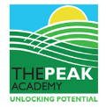

The Peak Academy Teaching and Learning Culture

This integrated policy combines:
• Dylan Wiliam’s Formative Assessment (FA) principles
• Trauma-Informed and SEMH Teaching & Learning approaches
• The Peak Learning Model

It provides:
• Consistent routines and shared language
• High expectations for academic progress and wellbeing

Introduction

The Peak Academy provides education for pupils between the ages of 11 and 16 years who have Education and Health Care Plans (EHCP) predominantly related to their Social, Emotional and Mental Health (SEMH) needs. By identifying specific needs and strategies on their EHCPs, the drive towards high quality teaching and effective learning is at the heart of what we do; and only the very best examples of teaching and learning will achieve our aims.

Curriculum Intent

Our goal for every young person is to develop the attributes, skills and experiences needed to ensure they are well equipped and ready for adulthood. The uniqueness of every child is recognised and valued. As such, we have designed our curriculum with pupils’ holistic needs at the centre of what, why and how we approach their learning and development. We have focused on three main areas of development, these are:

- Academic Rigour
- Social and Emotional Learning
- Therapeutic and Intervention support

Aims and objectives

- Ensure that consistent and effective teaching and learning is delivered across the curriculum
- Provide a set of guidelines for teachers to ensure that the curriculum is accessible to all pupils, meets their needs and challenges their learning
- Ensure that pupils are developed to become confident and independent, life-long learners both in and out of the classroom
- Close learning gaps by identifying barriers to learning and providing individualised curriculum strategies for intervention that accelerate progress for pupils

Our Ethos and Vision
At The Peak Academy, we believe every pupil thrives in a climate of respect, curiosity, and emotional safety. Our teaching culture nurtures resilience, independence, and a love of learning. We create spaces where pupils feel valued, supported, and inspired to achieve their best.
We create a love of learning by designing lessons that spark curiosity, celebrate success, and connect learning to real-life experiences. Teachers use engaging hooks, real-world examples, and pupil interests to make learning meaningful. Opportunities for choice and voice empower pupils to take ownership, while regular praise and recognition build confidence and motivation.

Creating the Right Climate
We foster calm, structured classrooms with predictable routines and positive relationships. Teachers use trauma-informed practice and restorative approaches to ensure pupils feel safe and ready to learn. Regulation spaces and strategies are available at all times, and daily emotional check-ins help pupils manage their wellbeing.
Regulation spaces are calm, low-stimulation areas where pupils can manage emotions and regain readiness for learning. Inside the classroom, this may include a designated corner with sensory tools, calming visuals, and seating options. Outside the classroom, a quiet room or outdoor area provides space for movement or reflection. These spaces should be signposted clearly and introduced to pupils during induction and revisited regularly. Teachers should proactively offer these spaces when pupils show signs of dysregulation, and pupils should feel confident to request access when needed.
Emotional check-ins help pupils express how they feel and prepare for learning. This might include using a visual feelings chart at the start of the day, a short one-to-one conversation, or a digital tool where pupils select an emoji or colour to represent their mood. Teachers use this information to adapt support and ensure pupils feel understood and ready to engage.

Principles of Excellent Teaching
Our teaching is guided by clarity, engagement, feedback, and pupil ownership. Teachers share learning intentions and success criteria in ways pupils understand, use questioning and discussion to include every pupil, provide timely feedback that moves learning forward, and encourage pupils to reflect and self-assess. Formative assessment strategies are embedded throughout lessons.

Subjects offered at The Peak currently:

Subject | Teacher/ Staff Responsible | Year Group Taught | Option at KS4 | Qualifications Offered
English | Cerys Jenkins | Year 7 - 11 | Compulsory | GCSE, Functional Skills, Entry Level
Maths | Jack Hobbis | Year 7 - 11 | Compulsory | GCSE, Functional Skills, Entry Level
Science | Elisa Entwistle | Year 7 - 11 | Compulsory | GCSE, Entry Level
Humanities (History, Geography and RE) | Chris Hyam | Year 7 – 9 | NA | NA
Literacy | Jak Evans | Year 7 – 11 | NA | NA
Physical Education | Andy Sprosen | Year 7 - 11 | Yes | GCSE Short course for those opting for additional PE
Art | Georgia Legate | Year 7 - 11 | Yes | GCSE
Design & Technology | Christian Glover | Year 7 - 11 | Yes | NCFE Level 1 creative craft/AQA GCSE Art and Design 3D Design
Food Technology | Angela Dare | Year 7 - 11 | Yes | Home cooking skills
Mechanics | Robin Meredith | Year 10 – 11 | Yes | ABC Level 1
IT | Dave Readman | Year 7 – 11 | NA | Functional Skills Level 1, Entry Level
RSHE | Dave Readman | Year 7 - 11 | Compulsory | NA
SEL (Social and Emotional Learning) | Jenny Pinkney | Year 7 – 9 (selective) | NA | NA
Btec Vocational Work Skills | Robin Meredith | Year 9 - 11 | NA | Personal Development  Level 1 Vocational
Construction | GYP | Year 10/11 | Yes | Gateway L1 Construction
Music | Music Works | Year 7-11 (pupils opt in) | Yes | Silver Arts Award

Peak Learning Model:

At the Peak Academy we use the model below as a structure to focus on learning with pupils. We understand that learning is continuous and should be flexible both within the lesson and across a sequence of learning to acknowledge where pupils are and to support learning moving forward. There is no time allocation for each section, teachers will respond, using ongoing formative assessment as to when to ‘move on’.

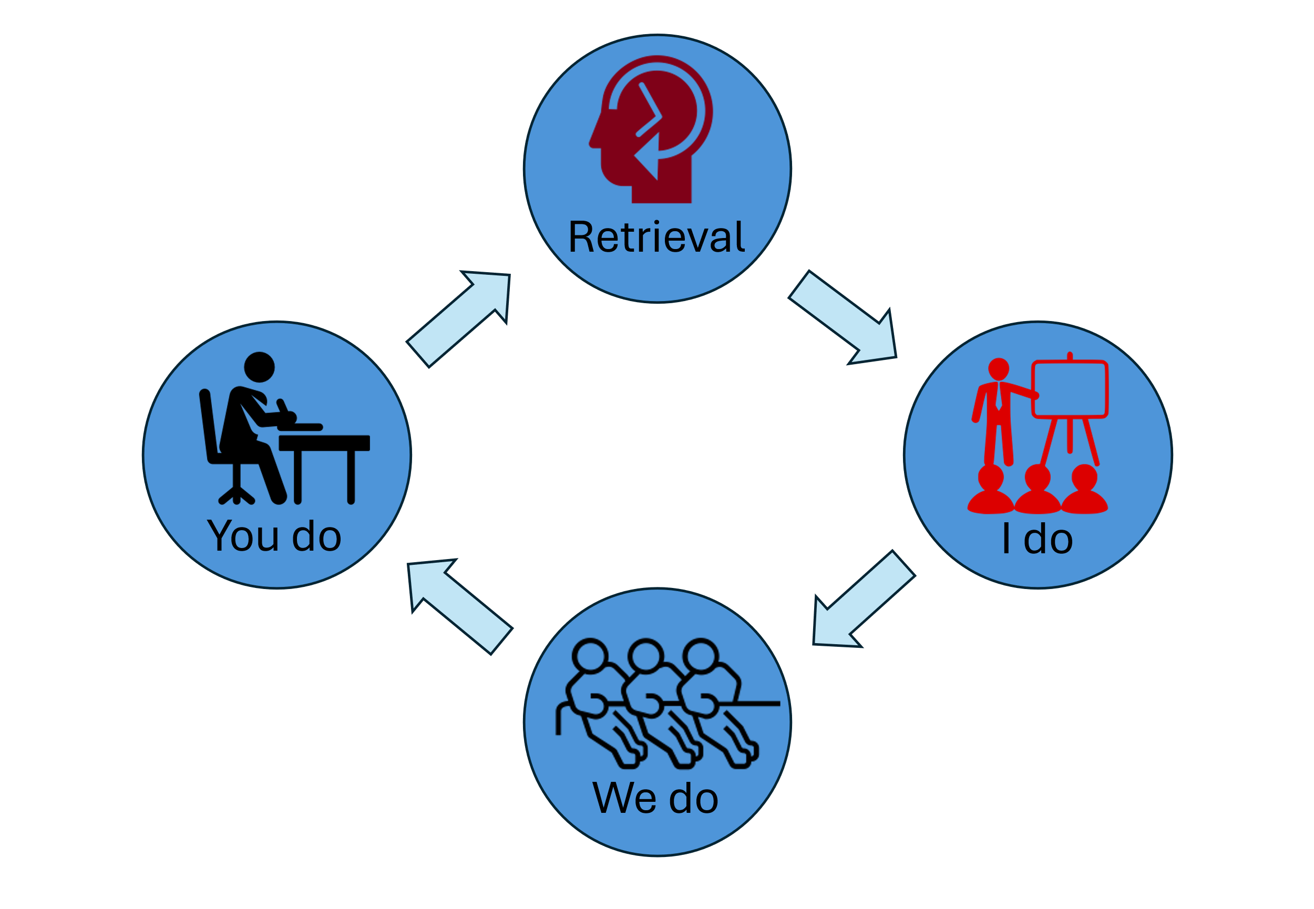
Retrieval - planned low stakes questioning on
previous work completed to develop long term
memory. This could include;
- Low-stakes recall tasks.
- Mini-whiteboards, cold call, pair discussion.
- Calm entry routines support regulation.
I do – teacher models’ new skills step by step through worked examples, thinking out aloud to help learners internalise the process. The aim is to avoid cognitive overload. This could include:
- Think-alouds.
- Success criteria unpacked with examples.
- Model includes misconceptions and emotional safety cues.
We do – the pupils work alongside the teacher to practice the new skills, closely mimicking the teachers’ model. Scaffolding may be offered at this point. This could include:
• Scaffolded tasks.
• Formative checks every few minutes.
• Co-regulation options (movement, sensory tools).

You do – pupils begin independent practice, some will still need guidance. Pupils should aim to use the worked examples from the ‘I do, We do’ part of the lesson.
• Gradual removal of scaffolding.
• Structured peer and self-review.
• Improvement time linked to feedback.

Classroom Routines
• Start every lesson with retrieval to strengthen memory.
• Model excellence and make thinking visible.
• Celebrate effort and progress using praise and recognition.
• Maintain calm routines and positive language at all times.
• Ensure success criteria are visible and understood.
• Provide opportunities for peer and self-assessment.

Continuous Improvement in Teaching and Learning

All teachers deserve professional development - not because they are not good enough, but because everyone can be even better. Our professional development is through a number of ways:

- Developmental Drop Ins (DDIs) - developmental, frequent, scheduled drop-ins from other professionals, which lead to actionable targets. These happen once a term and involve a 20 min Drop In followed by a feedback session as soon afterwards as possible. This discussion will be focused on what the observer has noticed that could make a difference and that is immediately actionable and manageable. Targets are always very specific and relate to the Peak learning model outlined above. These will be carried out by teachers’ line managers, unless it has been requested that someone else carries this out as part of a specific focus on a particular area of pedagogy, eg the SENDCo supporting the development of strategies to support specific need.
- A Developmental conversation linked to work being done on curriculum development will take place mid-year. This conversation will review pupils work / books to review the evidence of impact of the curriculum changes and the next steps in curriculum development.
- Embedding Formative Assessment (EFA) – this is linked to the two-year project, started in April 2024, written by Dylan Williams and run through SSAT. Staff will be supported through Teacher Learning Communities (TLC) and work in pairs focusing on good practice within formative assessment.
- Instructional Coaching – will be used with specific teachers that are requiring or asking for specific support. This can range from an ECT who is further developing their practice, a colleague who maybe struggling with a particular class or topic or where it has been identified through DDIs that more ongoing support is needed.
- Joint planning - can be put in for colleagues who are teaching a new subject or looking to develop a new scheme of work. It can also be used to help when planning for specific needs identified through pupil’s EHCPs. In addition, new ideas/ concepts may need a more collaborative approach to planning in its infancy prior to individual staff taking on responsibility.
- Deep Dives – to happen once per year for each subject. These will be a joint process between the subject leader and SLT member to identify and celebrate good practice within the subject, linking teaching and learning, curriculum plans, work in books and pupil views. Next stages of development are agreed and support planned as a follow up. Feedback and actionable time scaled steps are identified and monitored.
- Case Sampling is a structured approach used to evaluate how effectively the school meets the needs of priority pupils, such as those with SEND, social care involvement, or eligible for Pupil Premium. It triangulates evidence from key documents, classroom practice, pupil work, and pupil and teacher voice to check that strategies reduce barriers to learning and promote progress. These will take place in terms 1,3 and 5 and will be led by the SENCO.

Developmental Drop-In Feedback
Annex 1:
Purpose | To provide developmental, frequent, scheduled observations that lead to actionable, manageable targets focused on improving teaching and learning.
Observation Details | Teacher Name:  Observer Name & Role:  Date of Drop-In:  Time: | Duration: 20 minutes  Focus Area (if specified):  (e.g., SEND strategies, questioning techniques, classroom routines)
Observation Notes | (Brief, objective notes on what was observed.)  Strengths noticed:  (What is working well?)  Areas for development:  (What could be improved to enhance learning outcomes?)
Feedback Discussion | (Held as soon as possible after the observation.)  Key Observations Shared:  Teacher Reflections:  (What does the teacher think about the observation?)
Actionable Target(s) | Target 1:  (Example: Use cold-calling at least twice per lesson to increase engagement.)  Target 2 (optional):  Success Criteria:  (How will we know this target has been met?)
Support & Next Steps | Support Offered:  (Resources, coaching, peer observation, etc.)  Follow-Up Date:  (When will progress be reviewed?)  Guiding Principles:  - Keep feedback developmental, not judgmental.  - Focus on one or two high-leverage actions that can make an immediate difference.  - Ensure targets are aligned with the Peak Learning model and manageable within the teacher’s context.

Any of these can be used as an action step to develop classroom practice and can fit in any stage of the Peak Learning Model. Using these will give a consistent and simple starting point for an action. Feedback discussions following a DDI can elaborate/ support explanation linking the action step to what was seen in the lesson.

1. High Behavioural Routines and Expectations | 4. Making it Stick
a) Teachers demonstrate effective classroom management  b) Teachers consistently apply the school behaviour policy  c) Teachers ensure that there is a high ratio of pupil participation  d) Teachers reinforce effort and provide recognition  e) Teachers ask questions that promote pupil participation | a) Teachers regularly use low stakes testing  b) Teachers guide pupils as they begin to practice new material  c) Teachers give pupils opportunities to independently practice  d) Teachers use visual and other resources to support explanations  e) Teachers ask questions which make links to prior learning
2. Quality of Instruction | 5. Adaptive Teaching
a) Teachers give highly effective explanations  b) Teachers provide clearly defined learning outcomes  c) Teachers present new knowledge in small steps  d) Teachers model excellence and how to achieve it  e) Teachers set a high quantity of process and factual questions | a) Teachers provide scaffolds for demanding tasks  b) Teachers pitch high every lesson  c) Teachers adapt teaching as needs emerge  d) Teachers have a developed understanding of a pupil’s diverse needs  e) Teachers ask questions which are appropriately pitched and directed
3. Subject Mastery | 6. Assessment and Feedback
a) Teachers demonstrate expertise in exam specifications  b) Teachers plan for and address misconceptions  c) Teachers sequence and interleave content  d) Teachers promote and uphold the highest standards of literacy and oracy  e) Teachers ask questions which are specific and accurate | a) Teachers give pupils high quality feedback  b) Teachers accurately gather information on pupil learning  c) Teachers provide pupils with opportunities to act upon feedback  d) Teachers plan and ask questions that provide a picture of pupil learning

 | Case Sampling Template Form

Section 1 — Pupil & Case Details
Pupil ID / Initials:
Cohort (tick): SEND □ Social Care □ Pupil Premium □
Year Group:
Class/Subject:
Key Documents: EHCP □ Pen Portrait □ Behaviour Plan □ PEP □ Other:

Section 2 — Document Review Summary
Primary Needs/Barriers:

Intended Outcomes:

Provision/Strategies:

Section 3 — Lesson Visit & Work Scrutiny
Observation Focus:

Evidence Noted:

Work Sample Review:

Section 4 — Pupil Voice
What helps?

What hinders?

Sense of belonging/safety:

Section 5 — Teacher Check-in
Needs identification:

Progress checks:

EHCP knowledge:

PP strategy:

Section 6 — Evaluation & Actions
Judgement (circle): Secure & Embedded / Developing / Needs Attention
Immediate Adjustments:

Owner & Timeline:

Success Criteria & Review Point:

Completion notes
Leader Prompts
• How have approaches in key documents reduced barriers? What strategies are being used?
• In what ways will we see these approaches in the lesson?
• How have you used a graduated approach for this pupil?
• Have teachers received training/support in using a graduated approach?
• How do you identify pupils’ needs and check progress?
• What evidence informs pupil premium strategy?
• Do teachers understand and implement the pupil premium strategy?
• How is the local area partnership’s strategy enacted?
• How do you check PEP impact on learning opportunities?
Teacher Prompts
• How do you identify pupils’ needs?
• How do you check pupils’ progress?
• Knowledge of pupil documents (EHCP, pen portrait, plan, PEP).
• Knowledge of pupil premium strategy and PEPs.
• How have you used a graduated approach for this pupil?
• Have you received training/support in using a graduated approach?
Staff Knowledge & Implementation Check
• Knows key documents and classroom implications.
• Applies graduated approach (Assess–Plan–Do–Review).
• Understands and implements PP strategy in planning/teaching/feedback.
• Monitors progress and adapts provision accordingly.

Annex 3: Case sampling process / activities

