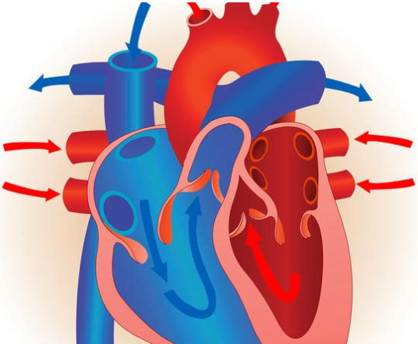
Eduqas GCSE PE Short Course Quiz
1. Which of the following is a component of health-related fitness?
A. Agility
B. Balance
C. Cardiorespiratory endurance
D. Coordination
2. What is the primary function of the cardiovascular system during exercise?
A. To produce hormones
B. To transport oxygen and nutrients to the cells
C. To digest food
D. To regulate temperature
3. Which type of training primarily improves muscular endurance?
A. Interval training
B. Circuit training
C. Flexibility training
D. Balance training
4. What is the term for the range of motion available at a joint?
A. Agility
B. Stability
C. Flexibility
D. Endurance
5. Which of the following is NOT a principle of training?
A. Specificity
B. Reversibility
C. Adaptability
D. Overload
6. What does the acronym FITT stand for in training principles?
A. Frequency, Intensity, Time, Type
B. Flexibility, Interval, Technique, Target
C. Focus, Intensity, Timing, Tempo
D. Frequency, Impact, Training, Tactics
7. What is the main benefit of a warm-up before physical activity?
A. To save time during exercise
B. To increase muscle cramps
C. To improve performance and reduce injury risk
D. To make participants tired before the main activity
8. Which of these is an example of a skill-related component of fitness?
A. Muscular strength
B. Flexibility
C. Reaction time
D. Cardiorespiratory endurance
9. What is the correct term for the body's ability to maintain equilibrium?
A. Strength
B. Agility
C. Balance
D. Power
10. How does regular physical activity benefit mental health?
A. Increases stress levels
B. Decreases energy levels
C. Improves mood and reduces anxiety
D. Causes sleeplessness
11. Which of the following nutrients is primarily responsible for muscle repair?
A. Carbohydrates
B. Fats
C. Proteins
D. Vitamins
12. What is the term for the maximum rate at which an individual can perform work using aerobic energy pathways?
A. Strength endurance
B. Anaerobic capacity
C. Aerobic capacity
D. Flexibility
13. Which training method would be most effective for improving cardiovascular fitness?
A. Plyometric training
B. Resistance training
C. Continuous training
D. Yoga
14. What is one of the primary goals of a cool-down after exercise?
A. To increase heart rate
B. To reduce muscle soreness and facilitate recovery
C. To stop sweating
D. To build muscle strength
15. Which body system is responsible for the delivery of oxygen to muscles during exercise?
A. Digestive system
B. Nervous system
C. Respiratory system
D. Skeletal system
16. What does the "overload" principle in training refer to?
A. Training harder every day without rest
B. Gradually increasing the intensity of exercise to enhance performance
C. Doing multiple training sessions in one day
D. Lifting the heaviest weights possible
17. Which factor is essential for maintaining a healthy weight?
A. High calorie intake
B. Regular physical activity
C. Eating only junk food
D. Sleeping less
18. Which type of joint represents a ball-and-socket joint in the human body?
A. Knee
B. Elbow
C. Shoulder
D. Skull
19. Which muscle is primarily used in a bicep curl exercise?
A. Triceps
B. Quadriceps
C. Hamstrings
D. Biceps
20. Which of the following is an example of an anaerobic exercise?
A. Marathon running
B. Powerlifting
C. Long-distance cycling
D. Swimming

