You will need:
- A pencil
- A rubber
- S6w2 A sharpener
- Paper
- A ruler
- Any other art materials you want to use – be creative

Task 1 – Still life drawing
1. Find 3 objects inside the house.
2. Put the objects next to each other
3. Draw the objects. Start with the outlines and then shade them with different tones to make them look life-like and 3D.

Examples:
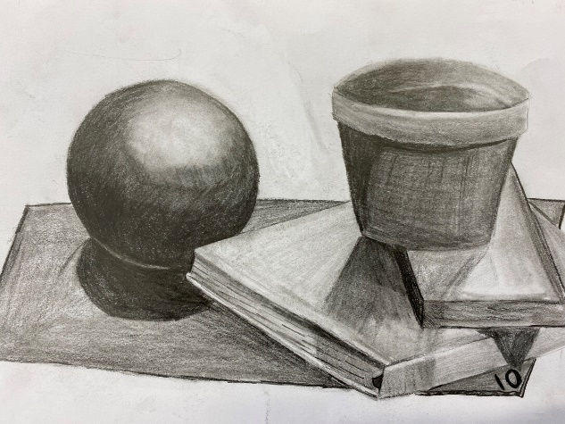
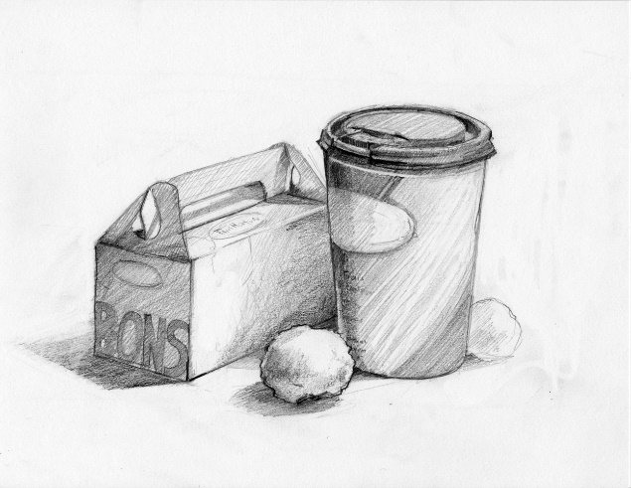

Task 2 – Landscape drawing
Ideas:
- Draw a picture of what you can see out of your bedroom window
- A place that is special to you
- Somewhere you’ve recently visited

Top tips:
Use a pencil to lightly draw the outline of what you can see.
You may need to use a ruler to make sure buildings are straight.
Remember, things closer up will be bigger and things further away will be smaller (this is called perspective)

Examples:


