
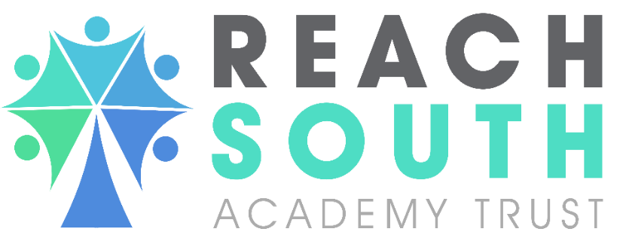

Feedback, Assessment and Marking Policy

Approval Date | December 2024
Policy Owner
 | Andy Vinton
Adopted by Trust Board
Review Date | December 2025

Introduction

Planning and assessment are always carried out for a purpose with the intrinsic aim of supporting student progress. Assessment that is both valid and reliable are invaluable in offering rigorous, systematic information to teachers to inform them of future planning and where pupils are at that moment in time.

Aims and objectives

This policy aims to help subject teachers identify:

- Where the learner is right now
- Where the learner needs to be
- How they get there

“…too many teachers focus on the purpose of feedback as changing or improving the work, whereas the major purpose of feedback should be to improve the student.”
Dylan Wiliam

Feedback (Formative Assessment) – to link with the EFA project The Peak Academy is currently undertaking

As professionals we will always aim to use the best feedback methods available to us. Rather than trying to make our approach fit the need for evidence, we’ve taken the opposite approach and instead we have suggested the evidence that may be found in our classrooms and books.

Feedback could be written or verbal, from the teacher, peers or themselves – but the intention is the same – to close the learning gap. Effective feedback has the following principles:

1. Feedback is regular so that students can redirect learning swiftly and make rapid progress
2. Feedback is specific so that students are in no doubt about how to close the gap
3. Feedback is timely so that students can respond shortly after the subject matter was first taught
4. Feedback is acted upon so that students can demonstrate that they have closed the gap

What this might look like in lessons:
Type | Possible Features | Evidence you may see
Live | ●Takes place every lesson with individual students or small groups  ●Provides an opportunity to redirect student or teacher action within the lesson (Adaptive Teaching). Feedback may be through re-teaching/ adapting following a misconception noticed during a task.  ●Students self-mark a short quiz and share the results  ●Often given verbally for immediate action  ●Sometimes will involve the highlighting or marking of student work  ●May involve the use of the teaching assistant to offer bespoke support  ●Often requires the student to respond to the feedback  ● Allows for a dialogue through questioning | ●Improvement evident in books through increasing development of work over time  ●Some of the features during a lesson observation  ●Some evidence of annotation of student work or highlighting in books where appropriate  ● Pupils self-assess in green pen  ● Staff feedback in purple pen
Review | ●Takes place at the end of a lesson or activity with whole class or groups  ●This could follow the Practice section of a lesson  ●Provides an opportunity for evaluation of learning in the lesson  ●Teacher leads guided feedback using a model answer following a piece of extended writing  ●Self or peer assessment against an agreed criteria  ●May involve re-teaching after a period of live feedback which has highlighted misunderstanding and is an opportunity to address misconceptions | ● Lesson observations  ● Bridging activity following assessment  ● Re-teaching  ● Guided feedback using a model answer  ● Consolidation task linked to a set piece of learning  ● Student response in books to verbal or written feedback (e.g. re-drafting, correction of work, improvement of a piece of work, additional work added)
Bridging | ●Takes place away from the point of teaching  ●Provides an opportunity for teachers to assess for understanding and redirect planning  ●May involve marking a piece of extended writing (appropriate to the subject)  ●May involve Whole Class Marking/ Auditing  ●May involve written comments/annotations on student work  ●May require a student to respond to feedback | ● Evident in books/folders  ●Individualised task linked to stubborn misconception from previous learning  ● Student response in books to verbal or written feedback (e.g. re-drafting, correction of work, improvement of a piece of work, additional work added)

Tracking pupils’ progress to assist planning and next stages of teaching.

Individual teachers should keep a record of how pupils are progressing. The minimum that should be used/ recorded:

Knowledge/ Skills tracker for each topic taught – reviewed by pupil and teacher (see below)

Minimum of 3 summative assessments (Term 2, Term 4, Term 6)

The grade issued for a data drop three times per year (see below). This should be a SMART assessment

Question Level Analysis (QLA’s); these will be done following Year 11 mock exams by core subjects and used to plan next steps for individual pupils.

Example of a Knowledge/ Skills tracker:

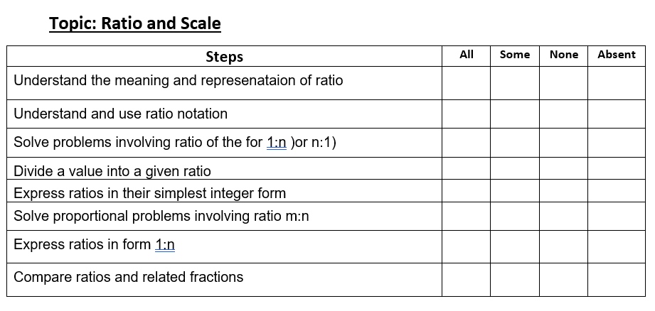
The structure and regularity will vary between subjects.

Summative Assessments

These are used at a particular point in time to find out what pupils know and do not know.
Throughout the year all pupils will take part in some/ all of the following

External examinations:
- These include GCSE, Functional Skills and any vocational linked assessment to KS4 qualifications.
- Pupils in Year 10 and Year 11 will undertake such examinations as guided by the exams officer
- In practice for these assessments, ‘walking-talking’ mocks may be used.

Internal end of year examinations:
- All year groups will have a minimum of 3 assessments (see above)
- Year 11 mock exams in December and March of their academic year.
- They will assess work completed over the academic year and done under exam conditions.

Baseline assessments:
- These are completed by any new pupil entering the school. They will assess the literacy (ART) and numeracy (AMT) levels of pupils and will support the setting of targets. Pupils will also be assessed using GL assessments, where available FFT50 scores are also looked at.

Data Drop grades:

Pupils’ progress will be judged against the 9-1 GCSE grading system in each subject. Within each subject the national curriculum identifies a number of outcomes that are required to be judged against. Each of these outcomes will have a 9-1 grade and a pupil’s current grade is based upon an average of all of these outcomes. In order to facilitate the lower ability pupils within the school a supportive structure has been implemented (S1-S5 for maths and English, S1-S3 for other subjects) to enable progress to be demonstrated for those below the 1 grade (no zero grades are given e.g. 0.5)

Progress will also be described against the level of competence within each grade.

Emerging (.1) – Pupil is starting to develop the concepts, methods and skills covered within the grade.
i.e. pupil is sometimes able to achieve the grade. Responses are simple using basic terminology/methodology within the grade.

Developing (.5) – Pupil is more familiar with concepts, methods and skills covered within the grade.
i.e. pupil is often able to achieve the grade. Responses are becoming more detailed, pupils able to describe and use a range of concepts/methodology with some success within the grade.

Secure (.9) – Pupil is secure in the concepts, methods and skills covered.
i.e. pupil is always able to achieve the grade and ready to move onto the grade above. Responses are clear and relevant, able to explain a range of concepts/methodology with pupils beginning to apply their knowledge within the grade.

For KS4 vocational subjects, enter the percentage of units completed at that point in time, for example 30% or 85%.

Marking

Evidence from the Education Endowment Foundation (EEF) states that written feedback has a lower impact compared to oral feedback, although both methods add towards positive progress.
The purpose of any marking will be to establish where the pupil is at that stage in time and to move learning forward.

What marking is required:
- Marking should be up to date and not left for long period of time.
- Work marked is that which is in work books, folders, IT based. Practical learning (e.g. badminton in PE, using different saw types in DT) can not be marked in the way outlined below. In these cases, verbal feedback and response is used to move learning forward, as outlined above.
- Learning/ practice work must be marked (examples, notes do not need to be marked). To be effective this needs to be done during the lesson. This can be done by the teacher, TA or the pupil themselves (the teacher should ‘scan’ any pupil marking to pick up and address errors).
- ‘Live’ in the lesson marking will take place, comments in books (where appropriate, not all discussions need recording) should be written during the Pupil 1-1 following discussions about their work. Pupils can do this to help them make a note of ‘learning’ and not just for the sake of it.
- Pupils should move learning forwards with corrections/ re-write etc when errors/ misconceptions have been identified.
- All vocational units in line with assessment plans. These should NOT be left to the end of the year.

Work Reviews:

The purpose of a work review within the quality assurance process is to:
- Identify good practice to be acknowledged and celebrated with the subject teacher, shared with others where it will help.
- Look at the standard of presentation of pupil work to include:
  - Learning/ practice work marked, errors and misconceptions addressed
  - Learning and the sequence of learning that progressively shows challenge and/ or development of new skills.
  - Encourage smart presentation. If there is a need for doodling, please provide appropriate resources to the pupil (doodle book)

- Challenge presented in the books against where they should be (reference made against reading ages). For example, if there are sizeable gaps in ability within a teaching group, is work differentiated enough.
- Pupils have acted upon feedback.
- KS4 unit assignments are marked in line with assessment plans.

